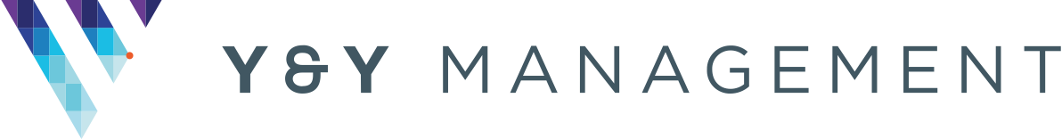

MONTHLY REPORT TO NOBEL HOUSE
Date: Thursday 28th July 2022
Short summary from Aaron about what has happened this month:
Alarm System / Waking Watch | Nothing further to report.
Removal of the small section of flammable Aluminium Composite Material (ACM) cladding systems | The removal of the ACM and replacement works are almost completed. We are aware some damage has occurred, but we will make sure that this is rectified.
Removal of the other, less-flammable, non – ACM cladding | The non-ACM fund has opened for applications, and we are in the process of making our claim for funding of the non-ACM remediation work.
Progress with application to the government’s Building Safety Fund | As above.
Update on NHBC Claim (this is insurance cover taken out when the building is built that should pay for any works required later due to failures in how it was originally built) | The NHBC have sent a full report on our claim which details those elements that they will accept. We are reviewing this to understand how this will impact the funding we have applied for.
Update on Hollybrook Claim (this is the claim against the original developer) | No further updated, they have not responded to our various letters.
ACTIONS for next month | We are now able to progress our non-ACM claim which will be our main focus.

Recent questions:
None submitted.
Other activities on site:
Nothing to report.

