Nobel House Residents Q&As 15.11.21
Below are the weekly questions on the Nobel House cladding issue, including responses to specific questions that residents posed.
Questions for Y&Y
Q1: If leaseholders pay service charges that we are invoiced for the works but which may later be covered by grants (eg the costs of professional advice from Capital), what guarantees are there that these funds will be protected if Y&Y cease trading due to the cash flow issues this will cause? Are funds held in a separate account, as they effectively remain the money of the leaseholders?
A: The funds are held in a bank account designed, protected and ring fenced for the various service charge payments, which is a condition of our ARMA regulation. The Government’s Building Safety Fund will also require that any funding will similarly be ring fenced for the purpose awarded. Additionally, If the company were to be insolvent, the funds are protected and cannot be used for any other purpose.
Therefore, all funds we have received for cladding works can only be used for the remedial cladding works.
Q2: We have recently received the set of documents you sent to Richard (Capital) at the start of their contract to assist with their investigations.
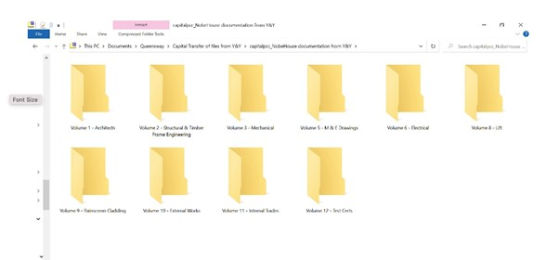
i) The screen shot of these files is above and we are wondering whether you have the missing folders, i.e. Volume 4 and Volume 7 or anything numbered 13 onwards? If yes, please can you arrange to send these.
ii) Also, where did you get these files in the first place, did they come from NHBC or the building owner?
iii) Do these files represent all the O&M manuals you have on file or are there others? If yes, please send them.
iv) Do these files represent all the specifications you have on file or are there others, in particular the original/architect specifications?
If yes, please send them.
A: i. These are the files we sent over originally. We only have sight of what was sent over. The files may either not be available or there is no number 4 and 7.
ii. They were on file from the developers.
iii. We do not have further documentation.
Iv. All the documentation sent is what we have on file.

