

RAVEN HOUSING TRUST LIMITED

SPECIFICATION (TO BE READ IN CONJUNCTION WITH THE
JCT MEASURED TERM CONTRACT 2024 EDITION AND
RAVEN HOUSING TRUST AMENDMENTS)

for

Supply and installation of replacement windows to houses and flats, windows to communal staircases and communal screen windows.

Project description
A 5 Year supply and installation contract for replacement PVCu windows to houses, flats, communal staircases and communal screen windows, as per schedule of addresses.

Comprising:

- Total of 1889 double glazed units to 226 occupied street properties to various locations Raven wide.

- Total of 2202 glazed units to 42 blocks of occupied flats to various locations Raven wide.

- Total of 88 glazed units to communal block stairwell windows to 14 blocks of occupied flats to various locations Raven wide.

- Total of 100 glazed units to outbuilding windows.
Scope
This specification applies to all windows and glazed screens, which are substantially made from plastic materials, in single, sub - divided or multiple coupled frame construction.

WINDOW SPECIFICATION - REPLACEMENT WINDOWS

REPLACEMENT WINDOWS - SURVEYING AND INSTALLATION
[TOP TIER]

REPLACEMENT WINDOWS - SURVEYING AND INSTALLATION

General

It should be noted that in order to reduce possible errors/confusion due to conflicting repeat clauses etc. the Replacement Window specification sections have been sub divided into tiers as per the table below.

Top tier | Middle Tier | Lower Tier
Replacement windows – surveying and installation etc. | Replacement Windows – General | Replacement PVC-u Windows

In this manner each completed product will be required to meet the specification of 3 No tier documents.

Example; if work to be undertaken is a Replacement PVC-u window, then the 3 No tier documents to be used will be;
- Replacement windows – surveying and installation etc.
  - Replacement Windows – General
    - Replacement PVC-u Windows

Initial Survey

001 A list of Properties will be given to the Service Provider with access details and the Service Provider is then responsible for arranging access, visiting the Properties, taking measurements and forwarding existing window dimensions and the Service Provider’s proposed style of replacement windows to the Client’s Representative for approval.

002 The drawings are to include ‘sketch elevations’ of each window showing the position of each proposed window type and to include details of opening casements and glass type for each window.

003 The proposals are to be approved by the Client’s Representative before the Service Provider commences manufacture.

Site Measurements

004 The Service Provider is responsible for ascertaining the correct dimensions and sizes of every existing window in each Property.

005 The dimensions noted on any schedule issued by the Client’s Representative are for guidance only and are approximate measurements. The Service Provider is responsible for taking all site sizes and measurements for each and every window opening, and for manufacturing windows accordingly and to BS 8213-4. (Windows and doors - Code of practice for the survey and installation of windows and external door-sets) and as recommended in the GGF (Glass & Glazing Federation) “Good Practice Guide for the Installation of Replacement Windows and Doors”.

This procedure requires a minimum of 8 No measurements both internally and externally to determine the difference between internal and external reveal sizes. Therefore, internal access to the Property must be gained before manufacturing the windows – this will also allow for full Customer consultation and agreement of intended Works. It is the Service Provider’s sole responsibility to obtain the Customers approval to receive the Works before manufacturing is commenced.

Windows are in the main fitted from the inside, although the nature of some reveals will permit replacement windows to be fitted from the outside.

The measurement and fitting of windows must in every case respect the existing cover / rebate to the outer frame of the windows by virtue of any “reverse brick detail” or “check reveal” that may pertain to existing Client Property.

006 Where a check reveal is present for weathering purposes, the window manufacturing sizes should be based on achieving a minimum frame overlap of 12 mm on the external leaf. A hole may be drilled thorough the existing frame jamb rebate to establish the check reveal size. A frame may also be built into the check reveal at the head by use of a rebated lintel, and again a minimum frame overlap of 12 mm should be provided where practicable. If an overlap of 12 mm cannot be achieved, this should be discussed with the Client’s Representative and an agreement reached regarding the size of the overlap for particular properties. As the Client owns a large stock of Properties, which vary in construction detailing, long term standard agreements to the amount of overlap will not be made with exception to the dimension stated here.

007 The Service Provider’s attention is drawn to the fact that similar windows in similar Property types may vary in size.

The Service Provider is responsible for ascertaining the correct dimensions and sizes of every existing window in each Property. Measurements for each window (and its location) must be clearly identified on any delivery schedule and each window shall have a clear labelling system to reflect this.

008 The use of make up pieces (clip-on’s / knock-on’s) will not normally be permitted except with the express written authority of the Client’s Representative. Written authority does not transfer to the entire Contract, if gained; it must be acquired for individual Property and/or phases.

009 Any existing window opening which will present the Service Provider with a problem in compliance with the Specification, or in manufacture of a window to suit, must be brought to the attention of the Client’s Representative before the window is fabricated. The Client’s Representative will issue a written Instruction informing the Service Provider of what action is to be taken.

010 The Service Provider must obtain signed consent from the Customer before manufacture of window is undertaken. The Service Provider should be aware payment will only be made on completion of the window being installed into the Property.

Guarantees

011 In addition to the Client’s rights under the Contract, the Service Provider is to provide the minimum guarantee tabled below against manufacturing defects etc., on all new PVC-u windows upon completion of the Works. The guarantee is to include for all profiles, joinery, and for the double-glazed units.

Manufacturers guarantees in all instances are to be for the years stated below with no exceptions attached (i.e. end user servicing expectations etc.), this will assure the Client that the manufacturer is confident of their own products durability.

PVC-u profiles | 25 Years
Hardware Components | 10 Years (minimum)
Double Glazed Units | 15Years (minimum)

Windows are to be manufactured under guidelines BS EN ISO 14001 (Environmental Management) and BS EN ISO 9001 (Quality Management Systems) with manufacturing companies holding the relevant accreditation. Manufacturers should promote and maintain an Environmental Policy and be committed to it. They should be able to demonstrate that all operations proactively comply with all applicable environmental laws and regulations.

The manufacturer shall provide a good practice guide relating to aftercare and maintenance of their manufactured window/sidelight etc. and its component items. The Service Provider shall ensure that each Customer receives a copy of this.

General Design of Windows

Windows - Street Properties

012 Generally the Design of windows to be replaced with storm-proof casements projecting top and side swing hinge.

013 However, each Property case may be different and therefore approval will be required for each Property. In all cases, the proposed new style of windows will need to comply with Building Regulations and in particular fire egress in terms of all habitable rooms and the requirements of Approved Document Part Q : Security – Dwellings.

014 The Service Provider is responsible for ascertaining the correct dimensions and sizes of every existing window in each Property.

Emergency Egress Windows - First floor and above

015 Every habitable room shall have at least one opening which shall comply with the Building Regulations Emergency Egress Windows, having an unobstructed openable area that is at least 0.33m2 and at least 450mm high x 450mm wide with the bottom of the openable area not less than 800mm and not more than 1100mm above the floor. Egress hinges should be included, where necessary. This requirement can be satisfied by the use of Securistyle Defender Egress Easy Clean Hinges. Note Fixed lights can be used to obtain a threshold height of as close to 1100mm as possible.

General Window Installation

016 All Windows and sidelights are to achieve an ‘A’ energy rating certificated by the British Fenestration Rating Council (BFRC).

All replacement sidelights must achieve Building Control standard of Maximum U-Value = 1.8 W/m²K for units with >50% internal face glazed.

U-values of windows glass and frames must meet the Building Regulations and must be BFRC Certified and have an “A” Rated Energy Index. Centre Pane “U Value” of 1.2W/m²K (or better). Thermal Transmittance Whole Window “U Value” of 1.4 W/m²K (or better)

017 All windows are to have “child restriction” to limit the uncontrolled opening of the window.

018 All windows must pass testing undertaken to PAS 24 and be Secure by Design certified. All certification documents are to be forwarded to the Client’s Representative and kept updated – this must include test certificate, report and list of tested ironmongery with product manufactures names, type etc. Evidence of compliance with PAS 24 (Specification for Enhanced security performance requirements for door-sets and windows in the UK) will be a condition of tender.

019 All new windows are to match existing size openings in existing positions (i.e. brick reveals to be maintained externally where necessary on all occasions).

020 Before installing the new window, the existing structural opening should be checked to ensure its stability and existing lintels checked to ensure their condition soundness. Any large repairs should be reported to the Client’s Representative.

021 It is permissible to “chip back” a small area of plaster (typically 25mm) extending full height up the existing reveals and immediately adjacent to the windows; this will both facilitate removal of existing window and installation of replacement window.

022 All openings should be cleaned of debris etc., and any minor making good is expected to be carried out as part of the window replacement works.

023 All metal fixings should be at least as corrosion-resistant as BS EN 1670 Grade 3. 13.5.

Windows shall be secured in accordance with the recognised “fixing distances” for strap / lug fixings and through-frame fixings as recommended in BS 8213-4.

024 s must be properly supported and fixed to ensure there is no likelihood of water penetration.

025 All internal reveals should be made good and plaster or decorations made good to match existing.

026 External sealing should be by means of a cement/sand pointing around the new window frame to conceal larger gaps and then a low modulus white silicone sealant to BS EN 11600. Only silicone sealants recommended by the manufacturer/supplier should be used and not general purpose mastics. All abutments of the windows should have silicone sealant applied.

027 Prior to installation the windows are to be supplied with adequate protection against damage caused by slippage, distortion etc. They must be stored under cover in a dry and secure position, stacked vertically, not horizontally.

028 The window dimensions must be checked with those of the opening before removal of the existing window.

029 A craft knife should be used to score around the perimeter of the existing frame in order to minimise damage to plaster/decoration.

030 Windows to be removed and all existing mastic and debris cleaned away. The Service Provider is to ensure that the work is carried out in a neat and tidy manner, with all rubbish removed to a lockable skip at the end of each working day.

031 The damp proof course is to be checked by the Service Provider to ensure one is present and in good condition. Any defects present are to be brought to the attention of the Client’s Representative immediately.

032 The new windows must be installed in accordance with the manufacturer’s requirements, taking into account the construction of the Property. Fixing methods should take into account thermal movement. The method of fixing will generally be either through frame fixing or lug fixing.

033 Windows must be installed plumb and square without twisting, racking or distortion of any member in accordance with the manufacturer’s installation tolerances.

034 The outer frame of the window must be centred in the aperture and be positioned so that it does not bridge the damp proof course. The amount by which the new window is set back from the outer face of the wall is determined by the requirement to set the internal face as close to the existing internal finishes as possible and by the bridging of the damp proof course.

035 The window frames must be secured so that the corner fixings are a minimum of 150mm and a maximum of 250mm from the corner of the frame and the intermediate fixings at centres no greater than 600mm.

036 No fixing must be closer than 150mm to a transom or mullion centre line. Should the manufacturer require more onerous fixing requirements then these must be adhered to. Care should be taken not to overtighten bolts and that packers/shims are not allowed to fall away. Care should also be taken to ensure that water tightness is maintained where lintels have to be drilled for fixing.

037 All screw fixing heads which pass through the profile are to be spot sealed with appropriately coloured or clear silicone sealer or a PVC-u cap.

038 Where electrical, television, telephone wires etc., enter a Property either through a hole in the existing window, or adjacent to it, then such services must be routed around the PVC-u window frame. A split plastic tube of suitable diameter and length for entry into the Property should be slipped over the cable so that connections do not have to be disturbed on the appliances, with the ends of the tube sealed with white silicone sealant on completion of the window installation.

039 Where any internal plaster work is disturbed when the existing windows are removed, the Service Provider must make good the plasterwork. PVC-u cover mouldings may be used to a maximum width of 30mm.

040 Bathrooms/WC windows must have obscured glazed window panes internally and one clear pane externally forming the double-glazed units.

041 The Service Provider is to include for removing existing internal window sills and renewing with suitably sized PVC-u window sills and any extensions to window frames required to raise height of window openings to 800mm from finished floor level internally if required.

042 Internally the PVC-u frame must be well caulked and the gap between the reveal finish and the frame flush pointed with a one-part white emulsion acrylic painter’s caulk.

043 The Service Provider must provide a matching cover bead at the junction of the internal window board or tile sill and the PVC-u window frame to all windows.

044 Each window must be permanently marked or labelled in an unobtrusive position (not visible when the opening light is closed) showing details of the manufacturer, the job number of the window and the date of manufacture.

045 The latest standard for glass units is BS EN 1279 –2 (also part 3 for gas filled types).

046 Special care and attention must be taken to protect and avoid any damage to windows. Any damaged window must be replaced with a new window, and it must be at the Client’s Representative’s sole discretion as to whether a repair to a window is acceptable.

Safety Laminated Glass

047 All glazing in windows in critical locations as defined by the Building Regulations (i.e. glazing below 800mm internal sill heights in windows is to have both skins of glass units glazed with laminated low E glass – assumed to be 2 No. skins of 6.8mm laminated safety glass.

Internal and external panes in sidelights, double glazing units to be laminated glass as default. An exception may be made where a staircase ends or turns immediately inside the doorway – in this instance the internal pane may be toughened (i.e. to reduce impact pressure) – written notification must be given to the Client’s Representative. External pane must always be laminated to provide security and satisfy PAS 24.

048 All safety glass is to be permanently marked on both panes with British Standard kite marks, which are to be visible after installation.

049 Both sheets of glass making up the sealed double-glazed unit must be safety glass where required by the above descriptions.

050 Details of windows in critical locations are to be stated in the Service Provider’s proposals for each new window when proposed drawings are forwarded to the Client’s Representative for approval.

Glazing - General

051 Windows must be manufactured so that glazing or re-glazing on site is possible without the need to remove the outer frame from the structure of the building.

052 All glass and insulated glazed units should be carefully examined for damage, especially at the edges, prior to installation. Defective items must not be used.

053 The two panes of glass in the double glazed unit are to be held apart with warm edge technology, spacer bars to improve thermal efficiency and reduce the possibility of condensation forming around the perimeter of the sealed double-glazed unit.

054 The glazing of the windows must be carried out immediately after the installation of the frames and casements.

055 On completion of window installations, all glass to be cleaned internally and externally and left clean and free from blemishes.

056 Any glass with scratches cracks or defects to be replaced by the Service Provider at no charge.

057 All windows to be INTERNALLY GLAZED in argon filled sealed units in low Emissivity glass, using pre-formed gaskets inserted during the profile extrusion and secured by knock-in PVC-U glazing beads with mitred corners.

058 All windows/sidelights will be totally dry-glazed with minimum 12mm wide x 3mm thick double-sided PVC foam closed cell high density security glazing tape on the inside frame rebates. Co-extruded EPDM corded glazing gaskets on the frame are acceptable as an alternative provided that bead security clips are used in conjunction with it.

059 All glazing to be clear glass except bathrooms and WC’s which are to be obscure Cotswold style glass or pattern group 5.

060 Glass shall be at least the minimum thickness to meet wind load requirements of BS 6262 and BS 6375.

061 Glazing beads are to be able to withstand the design wind loading in accordance with BS 6375-1 and the tests specified in BS EN 12211.

063 Fans are not permitted in sealed units.

064 Details of all glass types are to be stated in the Service Provider’s proposals for each new window when proposed drawings are forwarded.

Certificate of Test Window/Sidelight

065 All manufacturers of window/sidelight etc. shall be required to have a “sample” submitted for testing at an accredited testing station. These samples must be inspected against the requirements set out above. All manufacturers are required to have “third party” registration provided by BBA, BSI or equivalent recognised accredited quality licensing authority for the manufacture windows/sidelights etc.

066 A copy of the respective Certificate of Compliance for Secure by Design and PAS 24 must be made available at the time of submitting for inspection, which confirmations that the manufacturer can produce the product to the required standards, along with all testing data. The Service Provider should be aware these certificates may form part of the document handover pack and if not supplied on completion and handover of the Work, will incur a financial penalty.

Delivery to site of windows/sidelights etc.,

067 In each option, primary consideration must be given to current health and safety at work legislation in respect of site practices.

Option 1 – Pre-glazed

Will be valid where the window manufacturer is commissioned on a supply only basis; the installation, therefore, being undertaken by the Service Provider.

Option 2 – Un-glazed

Will be valid where the window manufacturer is commissioned on a supply and fit arrangement. This will involve the supply of insulating glass units and pre-formed glazing gaskets to be applied on site in accordance with the manufacturer’s technical data sheet.

Critical considerations to be observed:

- All glazing must conform to the recommendations contained in the relevant parts BS 6262–5 and BS 8000-7. The setting and location block positions, frame to glass and bead to glass gaskets etc. with any glass or insulating glass units must be installed in accordance with the relevant manufacturer’s technical data sheet and as per the recommendations in BS 6262–5;
- All insulating glass units shall be examined for damage prior to installation; defective units shall not be used.
- Insulating units with “low emissivity coatings” shall be oriented in accordance with the manufacturer’s technical data sheet; and
- Where safety glazing forms part of an glazing unit, it remains a legal requirement to ensure that the marking remains visible after installation.

Protection, Transportation, Storage & Pre installation check

068 The Service Provider must ensure the manufacturer/supplier is responsible for ensuring that all windows/sidelights are suitably protected to avoid damage during transportation and storage.

069 Windows/sidelights/glazing units (if applicable) shall not be flat-packed, but stood vertically during transportation.

070 Windows/sidelights/glazing units in storage to be “kept apart” preferably with soft packing to reduce risk of transport/handling damage.

071 The Service Provider must ensure that all windows/sidelights stored on site are housed within a secure weatherproof storage facility on-site until the time of fitting. Pre-finished joinery shall not be stored in direct sunlight.

072 Prior to commencement of installation, the Service Provider should undertake the following checks -
- Consult survey sheets and ensure these are correct and clear.
- All survey measurements are recorded.
- The windows/doors/sidelights supplied; are of the correct fenestration and design and in accordance with the window schedule approved by the Client’s Representative.
- The glass type and pattern are correct.
- Window and glass sizes are compatible.
- All trims, gaskets etc., are correct and fitted correctly; and
- Consult survey sheets to ensure windows supplied are correctly marked and identified to those Properties being replaced.

Site Approval on delivered

073 Previous to the benchmark Properties being set, a sample window / sidelight shall be delivered to site by the preferred manufacturer/supplier for inspection and acceptance by the Client’s Representative.

074 The manufacturer/supplier in providing the sample for acceptance must demonstrate full compliance with the specification requirements. Evidence of thermal efficiency standards being offered must be available to the Client’s Representative for verification.

075 The sample window (upon acceptance) will form the “benchmark window” for the remainder of the project.

076 The Client’s Representative shall reserve the right (at any stage) to have any window which is delivered to site, subsequently removed for further inspection/audit and/or independent testing to ensure that the specification requirements are being complied with.

Remove and install on same day

077 Existing windows to be removed are most likely to be PVC-u.
The Service Provider should make every effort to have all existing windows recycled and provide waste disposal reports to the Client’s Representative.

078 Replacement windows must be installed on the same day that the original windows are removed in order to maintain security and weather tightness of the structure. The existing windows should be removed with care in order to avoid damage to the Property structure and its finishes and without permitting any subsidence of the structure during or after the operation.

When providing numerous replacement windows to a single Property the Works should be undertaken on one set day to reduce the amount of disturbance to the Customer.

079 Any defects that become apparent in the integrity of the structure upon removal of any window should be reported to the Client’s Representative immediately.

080 If there is a sub-sill or threshold, e.g. Concrete, slate, brick or tile, below the existing window frame it must be left in position unless otherwise specified.

Protection of Existing Fixtures etc.

081 Allow for protection of floor coverings, furniture and Customer’s belongings throughout the duration of the Works.

082 The Service Provider is responsible for moving any furniture, fixtures and fittings that may be damaged during the installation of the windows/doors, prior to commencement of the replacement of any window/door and repositioning such items upon completion of the installation to each Property.

083 The Service Provider will be responsible for both internal and external protection. After the removal of the existing window/sidelight the Service Provider is to carefully cut back any internal or external flooring, finishings, cladding, wallpaper and decorations to allow for the installation of the new frames etc. The Service Provider is responsible for making good all structures, finishings and decorations up to 100mm from the face of the frame or sill.

084 The Service Provider must ensure that clean and sufficient dust sheets or protective coverings are used, when carrying out any Works. The Service Provider must ensure he has taken all adequate provisions to ensure that the soiling or damage to floor coverings and needless damage to decorations are avoided. The Service Provider must allow for any cleaning of floor coverings required as a consequence of the Works and this should be reflected in the tender Rates submitted.

085 It is recommended the Service Provider undertakes a Schedule of Condition and agrees this with the Customer prior to undertaking any Works. It is therefore considered prudent to take photographs of any damaged Customer’s belongings within the vicinity of the Work prior to commencement and, where appropriate, to obtain a signed disclaimer.

Fixings

086 Screws used for fixing non-reinforced PVC-u sections will be of carbon steel with a suitable corrosion protective coating and feature a double helical thread, spoon point with a countersunk head.

087 Fixings must incorporate a combination square/cross recess drive to provide a non-magnetic stick fit.

088 Fixings for friction stay applications will be supplied with a special low profile pan head to prevent fastener head interfering with the friction stay.

089 All screws, nuts, bolts and other fastenings must be of corrosion resistant material, or be treated to give corrosion resistant properties. When subject to the acetic acid salt spray test specified in BS EN ISO 9227 for a period of 144 hours, the corrosion resistance of treated mild steel must be equal to or better than that of stainless steel samples subjected to the same test conditions.

090 All ironmongery, fixtures and fittings must be of materials resistant to, or protected against atmospheric corrosion. Metals in contact with each other must be compatible so as to prevent galvanic corrosion of dissimilar metals by electrolytic action.

091 The use of polyurethane foam is not acceptable as a sole method of fixing any window into a structural opening, nor is it acceptable to be used as bedding for the window.

Fixing to be as recommended by in BS 8213-4 below is a brief summary, actual fixing recommendation should be taken from BS 8213-4 and its example diagrams:

Secured on all sides (where practicable);
Corner fixings – 150 – 250mm from external corner;
No fixings less than 150mm from centre line of a mullion or transom;
Minimum of 2 fixings per reveal;
If head is fixed with polyurethane foam, then head fixings can be –
• Frame width up to 1200mm – no fixings
• >1200mm to <2400mm – one central fixing
• >2400mm to 3600mm – two equally spaced fixings

092 The use of polyurethane foam is permissible in terms of “foam filling” and as a useful addition to mechanical fixings. When the window is completed and finished there should be no visual evidence of polyurethane foam either internally or externally.

Installation “packers” should be used to set the window frame onto to allow sealant/mastic to be used as a full fill bedding material. The colour should match the window finish.

Foam filling is to be used in all windows installations to provide a closure to possible cold bridge of gaps between the wall and the frame. It is only to be used within the depth of the window frame profile i.e. it should not be used to fill gaps to reveals etc. which are to be plastered. Form filling is only in regard to the following situations –

1) To the head of a window, where the presence of pre-cast concrete or steel lintels make it impracticable or pose significant difficulties in achieving the recommended fixing distances | Up to 15mm maximum
2) To the sides of frame to make up expansion/contraction gap left either side as a result of manufactured size of window | Up to 15mm maximum

093 All components should be supplied by a manufacturer complying with BS EN ISO 9001 accredited quality systems. A certificate passing warranty to the Client is to be issued by the hardware manufacturer on completion of the project.

094 Written confirmation of compliance with all of the above should be given to the Client’s Representative in advance of commencement on site and will be a condition of the tender.

Fire barriers

095 In all methods of construction it is important to ensure that the cavities between internal and external skins are protected at openings for windows from the spread of fire. If these openings are not protected, in the event of a fire, smoke and fire can spread through the cavity, causing danger to occupants in other parts of the Property not immediately affected by the fire. This issue is of particular concern in timber and metal framed buildings. Attention is drawn to the Building Regulations in respect of the requirement for suitable fire barriers to be present in such buildings. Guidance is given in BS 9991, BS 9999, and the current Building Regulations Approved Document B.

096 The method of construction should be identified, and where the building is of timber or metal frame construction, the type of cavity barrier should be established. Where the barrier is a cavity sock or similar, and is likely to become dislodged or damaged by the removal of the existing frames, this should be noted on the survey sheet, and instruction given to the installation team to ensure that the cavity barrier is either repaired or replaced to maintain the original level of fire protection for the Property.

NOTE: Timber and metal frame constructions usually have a moisture barrier included in the area around openings, to resist moisture ingress into the cavity that could affect the timber sheathing or metal studwork.” (Extract from BS 8213-4)

Insulated Cavity Closers and Insulation to Jambs

Insulation to window and door jambs must comprise:

50mm minimum front to back dimension, notional width 100mm, insulation to be securely built in between inner and outer skins at jambs with vertical damp-proof course.

Insulation to provide minimum 30 minutes fire resistance in terms of integrity and 15 minutes in terms of insulation when tested to BS 476 Part 20.

Thermal conductivity to be no greater than 0.038W/mK, insulation to be under compression within cavity and installed in accordance with the manufacturer’s technical data sheet and the Building Regulations.

Built in insulated cavity closers must comprise proprietary insulated cavity closer to flush reveal, to bridge between inner and outer skins at window and door reveals.

Cavity closers to be covered by a current BBA certificate or equivalent quality assurance certificate acceptable to the Client’s Representative.

Rigid PVC-u casing enclosing insulation with double flange to internal and external leaf to provide a key for rendering and plastering.

Thermal conductivity of insulation to be no greater than 0.038W/mK.

Cavity closer to provide minimum 30 minutes fire resistance in terms of integrity and 15 minutes in terms of insulation when tested to BS 476 Part 20.

Installed in compliance with current BBA certificate or equivalent quality system acceptable to the Client’s Representative.

Accessories: Manufacturer supplied compatible Polypropylene or PVC-u wall ties built in in accordance with the Manufacturer’s technical data sheet.

Built in insulated cavity closers must comprise proprietary insulated cavity closer to check reveal, to bridge between inner and outer skins at window and door reveals.

Cavity closers to be covered by a current BBA certificate or equivalent quality assurance certificate acceptable to the Client’s Representative.

Rigid PVC-u casing enclosing insulation with single flange to internal leaf to provide a key for plastering.

Thermal conductivity of insulation to be no greater than 0.038W/mK.

Cavity closer to provide minimum 30 minutes fire resistance in terms of integrity and 15 minutes in terms of insulation when tested to BS 476 Part 20.

Installed in compliance with current BBA certificate or equivalent quality system acceptable to the Client’s Representative.

Accessories: Manufacturer supplied compatible Polypropylene or PVC-u wall ties built in in accordance with the Manufacturer’s technical data sheet.

Built in proprietary insulated cavity closer to bridge between inner and outer skins at window sills:

Cavity closers to be covered by a current BBA certificate or equivalent quality assurance certificate acceptable to the Client’s Representative.

Rigid PVC-u casing enclosing insulation with double flange to internal and external leaf.

Thermal conductivity of insulation to be no greater than 0.038W/mK.

Cavity closer to provide minimum 30 minutes fire resistance in terms of integrity and 15 minutes in terms of insulation when tested to BS 476 Part 20.

Installed in compliance with current BBA certificate or equivalent quality system acceptable to the Client’s Representative.

Built in insulated cavity closers must comprise Proprietary insulated cavity closer to bridge between inner and outer skins at window heads.

Cavity closers to be covered by a current BBA certificate or equivalent quality assurance certificate acceptable to the Client’s Representative.

Rigid PVC-u casing enclosing insulation with single flange to internal leaf.

Thermal conductivity of insulation to be no greater than 0.038W/mK.

Cavity closer to provide minimum 30 minutes fire resistance in terms of integrity and 15 minutes in terms of insulation when tested to BS 476 Part 20.

Installed in compliance with current BBA certificate or equivalent quality system acceptable to the Client’s Representative.

Making Good

097 The final covering and treatment of surfaces and their intersections are fundamental to the overall replacement of windows:

The primary objective of making good, damaged areas adjacent to the windows is to maintain the;
- Weather-tightness; and
- Thermal performance characteristics

As required in and around reveals.

098 This protocol described below applies to all window replacements and shall be undertaken as the primarily aim to negating the need for any redecoration during/after window installation.

There will be a number of situations (i.e. age of the Property; thickness of plaster reveals; and to some extent “build issues” associated with system-built dwellings) that it may not be possible to observe all or part of this protocol. Therefore more damage may be required to the reveals and/or the window/wall to undertake the required window replacement. This could result in the need for some redecoration. Where this is likely to occur, firstly the Service Provider is required to notify the Client’s Representative at Design stage. If however this is not identified until on-site stage the Service Provider must note the Properties affected and alert the Client’s Representative before work commences.

Where full plaster reveals are to be undertaken – i.e. Internal and external making good; this may take place on subsequent days, but the whole operation from start to finish of each window must not exceed 3 No. consecutive working days.

099 Plaster-Patching - This process will require a small degree of plaster-patching. This will include the following areas -
- All of the reveals immediately adjacent to window frame etc.;
- Part of the reveals where strap/lug fixings have been employed.

Finishing Trims are to be Cellular extruded PVC-UE trims/beads and must conform to BS 7619 and as the below table.

 | Internal Reveal  (3 sides) | External Bead  (3 sides) | Internal Sill Board
Single bull-nosed PVC-UE trim typically 5–7mm maximum thickness | 
Trim width must not exceed 100mm
Quadrant / Bead typically 12x12mm or 18x18mm maximum  OR  Single bull-nosed PVC-UE trim typically 5 – 7mm maximum thickness |  | 
Trim width must be in range 20 – 25mm maximum
PVC-UE Cloaked Trim typically 10–12mm in thickness in every case over-cladding the existing timber sill |  |  | 
Removal of existing sill boards is not permissible as substantial damage is normally inflicted on window wall within rooms

100 Trims are not to be used to simply provide or enhance the weather tightness of the window or any perimeter joints. Finishing trims shall be used to neaten the interface between frames and opening, they are only to be used in conjunction with the “plaster-patching”/making good situations as stated above. All joints must be left ‘neat and tidy’ with an acceptable tolerance of +/- 2/3mm on all joints/trim abutments and sealed with sealant of matching colour.

101 Internal finishing trims shall be compatible with the material of the window frame and must be colour-matched.

102 External finishing beads/trims shall satisfy the above criteria and be of an exterior quality material used in accordance with the manufacturer’s technical data sheet. External beading is not required where the external reveal has been re-plastered to match existing.

For the avoidance of doubt, windows should be measured and fitted as described above and beads/trims should only be fitted to the opposite side of the determined cover/overlap. Only in exceptional cases where reveals are determined as flush will internal and external beads/trims be acceptable.

Fixing of Trims/Beads

103 All internal trims shall be secured in every case to a firm backing (junction of frame and reveal/existing sill) with a low modulus silicon sealant (as below) and sealed all round.

All external beams/trims shall be secured in every case to a firm backing (junction of the frame and plaster reveal) with the low modulus silicon sealant (as below) and sealed all round.
Sealants

104 Sealants must comply with BS EN 11600 and be low modulus grade.

105 Perimeter joints externally and internally around the “as installed” window shall be sealed with a low modulus silicone sealant and “smoothed” to provide a good seal.
The sealant shall be appropriate to –
- The frame surface and colour;
- Any substrate material;
- The specific joint size and configuration; and
- Potential joint movement and weather exposure.

Implications - Customer’s Blinds etc.,

106 The inclusion of a finishing trim to existing reveals and sill may in certain circumstances create an issue around the re-fitting of Customer’s blinds etc. The Service Provider shall pay due regard to the existing window dressing(s) and where finishing trims are required that a “slim-line” version (5mm or less) is used.

Repairing damaged prefinished coatings on site

107 Localised repairs to coatings shall be affected by brush application on site using the same coating Material and build-up as the factory application with no discernible difference upon completion. All repairs shall be carried out in accordance with the joinery manufacturer’s technical data sheet, by a competent person and to the satisfaction of the manufacturer and Client’s Representative to ensure continuance of the warranty.

Cleaning of Windows

108 The protective tapes shall be removed from the as installed windows immediately or as soon as practicable after installation and the window (frame and glazing) cleaned with a suitable cleaning agent.

Final Completion Checks

109 Upon final completion of each and every window installation, the Service Provider is to confirm and check the following: -
- All glazing beads are adequately fitted and in good order.
- All hardware functions and locks operate correctly and are not stiff to use.
- All frames and glass are free from cracks, breaks and scratches etc. All frames and glass are cleaned, and all internals of frames are swept clean.
- All openings are square and operate correctly.
- There is no movement to the window.
- All restrictors, vents and hinges etc. are clean and operate correctly.
- All making good internally and externally is completed; and
- All trims are clean and sealed.

110 Once all the above items are completed, the Service Provider is to demonstrate the operation of the window to the Customer and provide the Customer with their own operating instructions for the windows. In addition, the Service Provider is to provide a Customer Satisfaction Card (to be supplied by the Client’s Representative) which the Customer is requested to complete and return by free postage to the Client. In due course the Service Provider will be required to provide any means necessary to allow the Customer to sign Satisfaction Card electronically for uploading to the Client’s Asset Management software.

Photographic Evidence - Removal/Installation of Windows/Sidelights

111 The Service Provider is required to take digital photographs of each completed window/sidelight installation.

The photograph should clearly show the completed internal reveals and identified by address and room (i.e. this may be done by placing an address and room labelled clipboard against the window at the time of taking the photograph – ensure clipboard does not block image of window).

112 The photographs should be retained electronically by the Service Provider and if requested provided on an individual basis to the Client i.e. in the event of any Customers making a claim against the Client.

113 The Service Provider should note that the Client’s Representative will from time to time ask for evidence of these photographs and how and where they are stored. The Service Provider is required to retain these images for at least 6 years after the Date of Completion (in accordance with the Client’s Retention of Documents Policy and legal timeframe for a Customer to make a claim).

Compliance Standards

114 The installer shall be a F.E.N.S.A. member and provide certification for each installation.

REPLACEMENT WINDOWS – GENERAL
[MIDDLE TIER]

REPLACEMENT WINDOWS - GENERAL

General

001 This section is to be read in conjunction with the ‘Replacement Windows and External doors – Surveying and Installation’ section, which provides details of surveying, sampling, installation, finishing etc. – generally as per BS 8213-4 (Windows and doors - Code of practice for the survey and installation of windows and external door-sets).

002 All Windows and sidelights to achieve an ‘A’ energy rating certificated by the British Fenestration Rating Council (BFRC).

Windows Openings

005 All windows to be fitted with opening restrictors and as far as practical Egress Easy Clean Hinges. All windows to be fitted with restrictor hinges to permit the windows to open to 100 mm maximum in the restricted position. On restricted hinges the release mechanism shall be an integral part of the hinge and shall self relocate in one action on closure of the vent. All components, rivets and pins should withstand a force of 600 Newtons to comply with BS 6375:Part 2 and BS 8213:Part1:1990. All side hung windows can be restricted by a single restrictor hinge positioned at the bottom of each casement. All to meet BS 6375:Part 2 and BBA Approval Ref:1227. This requirement can be satisfied by the use of Securistyle Defender Restrictor Hinges or equivalent.

006 All hinge components such as bottom track, link bars and rivets to be manufactured from Austenitic stainless steel to BS EN ISO 10088-2 Grade 1.4301 and fitted in accordance with manufacturer’s technical data sheet limitations and recommendations. All associated hardware should be approved to PAS 24 and meet BS EN 1670 Class 4 corrosion resistance.

007 All ground floor windows and any designated vulnerable windows to be fitted with the ancillary security devices as hinge protection. This device is to be of a type of "non-contact" in normal operation of the window and passivated to withstand 500 hour neutral salt and spray test. To meeting BS 7950. This requirement can be satisfied by use of Securistyle Vector Excluder or equivalent.

008 Easy clean facility to allow the window to slide along the hinge track so as to be cleaned from inside the building to BS 8213-1. After cleaning, the hinge should allow the window to self-relocate and return to its original position and mode of operation simply by closing the casement.

009 All hinges should be BBA Approved or equivalent and to include a thermoplastic end point and die cast end cap with self-lubricating surface finish featuring a roof to minimise the build-up of debris.

010 Windows, after a considered and noted risk assessment, can be fitted with a clearly visible and intuitive to release restrictor.

011 The release mechanism must self-relocate in one action on closure of the vent. All components, rivets and pins should withstand a force of 600N to comply with BS 6375-2, Performance of windows and doors. Classification for operation and strength characteristics and guidance on selection and specification and BS 8213-1 - Design for Safety in Use and During Cleaning of Windows.

012 Restrictor to be tested to comply with BS 6375-2 to withstand a force of 600N when opened at the restricted position and fitted to provide a maximum opening of 100mm in the restricted position. Restrictor to be manufactured from stainless steel to BS EN ISO 10088-2 Grade 1.4301 tested to meet the requirements of BS 7412 and to meet BS EN 1670 Class 4 corrosion resistance.

The protective tapes shall be removed from the windows immediately or as soon as practicable after installation and the window cleaned with a suitable cleaning agent.

013 Written confirmation of compliance with all of the above should be given to the Client’s Representative in advance of commencement on site.

Weather Performance and Seals

014 All new windows must be approved to BS 6375-1 (Performance of windows and doors. Classification for weather tightness and guidance on selection and specification) to the below levels and will achieve a Class A for mechanical testing to BS 6375-2 (Performance of windows and doors. Classification for operation and strength characteristics and guidance on selection and specification): -
(a) Air permeability – 600 Pascals minimum
(b) Water tightness – 300 Pascals minimum
(c) Wind resistance according to the design wind loading but not less than 2400 pascals.

All framing including mullions, transoms and couplers shall be capable of withstanding the design wind loadings calculated in accordance with BS EN 1991-1-4:

015 Weather stripping and glazing gasket Material must not have a detrimental effect on the plastic profile.

016 Weather strips for PVC-u windows to be co-extruded weldable seals and white gaskets approved to BS 7412 and BS 4255 to increase the weather tightness of the windows.

017 The weather-stripping must be capable of being renewed without disturbing the glazing system and without removing the outer frame from the structure.

018 The weather-stripping must be continuous around the frame.

019 Weather strip seals and draught excluders between all sashes to be included for all windows.

020 Glazing gaskets must be thermoplastic elastomer (TPE) and must be pre- inserted into the profiles.

Window Ventilation

021 All window units are to be provided with trickle ventilators to provide 8000mm2 areas to each habitable room and 4000mm2 areas to kitchen, bathroom, WC and utility rooms.

022 The ventilator is to be fitted with an insect mesh in accordance with the requirements of BS 5440-2 and BS 7372-1. Trickle ventilators must be manufactured from either aluminium section with powder coated finish to match window colour, or high impact modified PVC-u.

All ventilators are required to have their ‘equivalent areas’ from testing clearly marked on the device. The fitting of cording or rod devices to ventilators, ensuring ease of use by the Customer, to be in accordance with the latest guidance in the Building Regulations Approved Documents.

023 The Service Provider is to ensure that all window Designs to habitable rooms have a window opening area of no less than 5% of the floor area. The Service Provider must bring to the attention of the Client’s Representative any window Designs included in this Specification that he believes does not meet this criterion, before the manufacture of any windows.

024 The type of trickle ventilator to be fitted is to be “glazed in”. Due to the Client’s requirement that all PVC-u window frames must be fully reinforced (i.e. metal inserted into all profile members) “through frame” design is not permitted on PVC-u windows.

Child Restrictors

026 Child restrictors are to be fitted to all windows with openings on all floors. The restrictors must not allow opening the window more than 100mm without using the restrictor switch.

027 Type of restrictors to the PVC-u windows are to be integral/in-built to hinge or push type fitted within frames on all casements outward openings and the PVC-u switch built into the top sashes on PVC-u sliding sash windows.

Window Furniture

029 Window furniture to openable sashes to be positioned in the centre line of the frame unless indicated otherwise.

030 Push button handles to be fitted to all window openings. Ground floor windows and doors and those that are easily accessible must have key operated locks (unless designated "Egress"" in which case key locks are not permitted)

031 Details of window furniture are to be provided by Service Provider and approved by Client’s Representative.

032 All handles to casement windows to be lever handles operating a multi-point espagnolette shoot bolt locking system with auto lock button cylinder lock. PVC-u window handles to be white powder coated aluminium.

033 All side hung casement windows to be fitted with egress hinges with the lower hinge being integral push button restrictor mechanism for two handed full opening operation.

034 Top hung casements to be easy clean hinges of sufficient size to allow easy cleaning from the inside and integral push button restrictor mechanism.

035 There must be a correct correlation of hinge/friction stay capability with maximum vent weight and vent sizes i.e. sash sizes must be no larger than the hinge manufactures product table recommendations.

037 Hardware with provision for adjustment must be accessible for adjustment after the window has been installed. Hardware used to open/close the window must be replaceable without removing the outer frame from the structure.

038 All components should be supplied by a manufacturer complying with BS EN ISO 9001 accredited quality system.

039 Ironmongery product manufactures limitations must be strictly observed within the terms of their conditions of supply. It is the responsibility of the fabricator/purchaser to ensure that the performance of the window complies with the relevant standards and specification requirements for the particular window and that the correct product is chosen for the weight and design of each window system. The Ironmongery manufactures product information to be provided to the Client’s Representative as required.

040 Window hardware wherever applicable must be supplied from a manufacturer holding a product licence under the auspices of the Home Office “Secured By Design” initiative with the aim of fulfilling the obligations placed on the housing provider to ensure a reasonable level of security to the occupants as outlined in Section 17 of the Crime and Disorder Act 1998.

041 Written confirmation of compliance with all of the above should be given to the Client’s Representative in advance of commencement on site.

Locking Mechanism

042 All windows to be fitted with a Locking Mechanism that must be BBA accredited or equivalent and have been tested to the equivalent of PAS 24 security test or a Secured by Design Licensed Product. The locking mechanism is to be a Shoot Bolt Locking System operated by a single handle. Profile system specific zinc die cast alloy keeps should allow for secure night vent position. Abuse tested to 45 N with keeps blocked. Gearbox is to be sealed to stop the ingress of swarf during manufacture and use. All components to be proven fully functional after 500 hours neutral salt spray test to BS 7479. All components should be supplied under the auspices of an official licence holder of the Home Office "Secured by Design" partnership and to comply with BS 7950 accreditation. This requirement can be satisfied by the use of Securistyle Vector Shoot Bolt or equivalent.

043 Locking mechanism to have an enhanced grade zinc alloy gearbox and mushroom-headed cams and shoot bolts. Where twin cam type is used, shoot bolts are not required. Minimum corrosion resistance: BS EN 1670 Class 3. Fully adjustable “Twin Cam” high performance “no crop” security locking system. Operate with up to four pairs of mushroom cams travelling towards each other locking into a double-sided security keep. Fully adjustable cams ± 1mm. keeps with a night latch locking facility.

044 All window hardware should meet BS EN 1670 Class 4 corrosion resistance.

045 All components should be capable of sustaining a minimum of 25,000 opening cycles and 1,000 full reversables under 50kg operational load without demonstrating any significant deterioration or deformation that would inhibit its function and have a Mechanical Guarantee/Warranty required (as a minimum) - 10 years.

Operating handles to be push to release, key deadlocking, offset, white polyester
powder coated with push to fit screw covers. One key is to be supplied with each
handle. Egress windows to be fitted with non key locking green egress push to release handle.

Implications – Customer’s Blinds etc

046 The inclusion of a finishing trim to existing reveals and sill may in certain circumstances create an issue around the re-fitting of Customer’s blinds etc. The window manufacture shall pay due regard to the existing window dressing(s) taking note of where finishing trims are required that a “slim-line” version (5mm or less) is used for sizing of window and ensuring correct allowances to ensure sash opening.

Cleanability of Window

047 All windows must be cleanable from the inside and the design of openings and fixed units is to meet the access standards recommended in BS 8213: Parts 1-3 and Code of Practice 154.

048 New PVC-u sliding sash windows must be capable of tilt inwards to allow for cleaning and to have secure brackets fitted within the frames to hold each sash in position when tilted inwards for cleaning.

REPLACEMENT PVC-u WINDOWS
[LOWER TIER]

REPLACEMENT PVC-U WINDOWS

MATERIALS AND MANUFACTURE

PVC-u Windows

001 This section is to be read in conjunction with the general specification for ‘Replacement Windows and External Doors – Surveying and Installation’ and ‘Replacement Windows – General’.

002 All new PVC-u windows shall be purpose made BBA approved or equivalent, fully welded and fully reinforced PVC-u to BS 7412, BS EN 12608, PAS 24 and Secured by Design certified.

003 The windows fabricator/contractor is to be a licensed kite marked manufacturer to BS 7412, and all products to be covered by BS EN ISO 9001 and an ‘A’ energy rating certificated by the British Fenestration Rating Council (BFRC).

PVC-u Window Installations Specific

004 To all windows where timber sliding sash windows are to be removed and replaced with PVC-u windows, the Service Provider is to include for new windows to have pressure treated timbers around the windows wrapped in damp proof course to infill the old window sash boxes. The timber packers to then be covered with PVC-u clip on liners, and small gaps filled with polyurethane in-situ foam with closed cell structure between 65% and 75%.

005 Under no circumstances are the old box frame cavities to be filled with foam only. Plaster is then to be made good and new plaster covered with wider PVC-u architraves to reduce damage to wall decorations.

006 The use of ‘make-up’ pieces (clip on’s) as means of standardising manufacturing sizes should not be used under any circumstances without the prior approval of the Client’s Representative. In only special circumstances will approval be given, and then the make-up size should not exceed 15mm either side or head.

PVC-u Windows Section Profiles and Reinforcement

007 Extruded window profiles shall only be those itemised on the window manufacturer/contractor’s kite marked licence and the type testing carried out by a third-party testing house to BS 7412.

008 The Material from which the extruded four chambers profile sections are made shall consist of white high impact modified un-plasticised poly vinyl chloride with a class 1 surface spread of flame resistance to the requirement of BS 476.

Manufactured and extruded hollow PVC-u profiles to BS EN 12608. PVC-U Material shall have a multi-chambered design (5 chambers minimum) for enhanced thermal efficiency.

009 All joints to be welded joints with a grooved finish.

010 Reinforcement to be installed to all casement and frame members.

For window forming glazed screens the reinforcement shall be identical to that described in the type testing results to BS 7412 and details must be made available on detailed drawings.
Where windows cannot achieve the gusting requirements of this document (in accordance with type testing to BS 7412) they shall be sub-divided with columns incorporated between the divisions. These structural columns shall meet the gusting requirements specified and be expressed in Pascals.
In addition, for any windows that are load bearing or structural, taking loads from
roofs etc (i.e. bay windows), the new windows must be designed to take the same loads by means of structural members, corner posts etc that must fully and
adequately transfer the loads to the structure below the window. The contractor must serve a Building Notice in respect of any structural windows and provide temporary support. Calculations proving the adequacy of the structural members must be provided.

011 Reinforcement is to be fixed with self-tapping stainless-steel screws to BS EN ISO 3506-1 and 2 or, sheradised coated steel screws at 300mm centres so that the reinforcement does not move or rattle when the window is in use.

012 Reinforcement must be made of hot dipped coated steel reinforcement to comply with BS EN 10346 or Aluminium reinforcement to comply with BS EN 485-2; BS EN 515 or BS EN 755-9 (as laid down in BS 7412) or hot dipped prime galvanised steel complying with BS EN ISO 1461, BS EN 10132 and BS EN ISO 9015.

013 The profile must be extruded from un-plasticised polyvinyl chloride (PVC-u) therefore recyclable at the end of its life. Only those additives and pigments may be used that are needed for the manufacture of the compound and its subsequent conversion into sound, durable extrusions of good surface finish and mechanical strength, as assessed by the requirements of this specification.

014 The PVC-u Material frame, that the profiles are to be made from, must conform to the specification given in Table 1. The tests must be carried out on pressed plaques prepared from milled sheet*, under standard conditions as specified in BS EN ISO 1163-2. (* with the exception of the impact tests which are carried out on samples cut from the face sides of extruded profile.)

015 Profile wall thickness to be classified in accordance with the requirements of BS EN 12608 (Unplasticised polyvinylchloride (PVC-u) profiles for the fabrication of windows and doors. Classification, requirements and test methods).

016 The colour of the profile must be uniform and the colour of the profiles in a system must be uniform. The finish of the windows is to be white to 40% Gloss (RAL 9003 equivalent). The profile must be free from foreign bodies, cracks or sink marks when viewed by normal corrected vision at 90 degrees to the surface and at a distance of 1 metre in normal diffused north light.

017 The profiles must be straight such that the longitudinal axis of the profile as measured on the face surfaces may deviate from the straight line by no more than 1mm/metre.

018 Tolerances on external dimensions (from BS EN 12608)

External dimension | Tolerance
Depth (D) ≤ 80  > 80 | +/- 0.3  +/- 0.5
Overall width (W) | +/- 0.5

019 No rework/regrind material is to be used in any section, which will be subjected to any weathering. Rework/regrind material will only be allowed in internal glazing bead extrusions.

Construction

020 All corners and intersection joints between frames, mullions and transoms must be welded.

021 The excess material created by the welding process must be removed by a grooving or flush surface method. In either case, the method used must not weaken the profile or the joint and must retain sufficient wall thickness.

022 Only where Instructed by the Client’s Representative must windows be provided with external projecting PVC-u sills. The sill must be from the same manufacturer as the PVC-u windows. To be of sizes appropriate to maintain the projection of existing sills beyond the face of external walls.

023 These sills must be properly supported, and hollow sill sections must have end caps to ensure that no water penetration occurs at the end of the sills. The sill and window frame must be jointed in accordance with the manufacturer’s technical data sheet to ensure water and weather tight joint.

024 Insulated infil panels will be required where indicated on the Schedule of Window/Door Types and drawings.

025 The panels are to consist of decoratively coated fibre cement-based board or cladding.
All panels to be manufactured to meet all relevant building regulations and safety standards with regard to thermal performance, acoustic transmission and fire protection.
The colour of the panels must be approved by the Client’s Representative, prior to the Service Provider ordering the panels.

026 The finished window must be free from all sharp edges, burrs and the like that might be a hazard to the user.

Performance Requirements

027 All windows are to comply with BS 7412 and BS EN 12608.

028 The Service Provider must be able to provide test reports prepared by a UKAS accredited testing house to confirm that the windows meet the criteria. The Client’s Representative reserves the right to have any window provided for the Contract tested to check its compliance with these performance requirements.

029 The new BS EN test methods are more demanding than the old. One major factor is the introduction of a final ‘safety test’ on windows. A 2000 Pa exposure rated window would have to withstand a ‘safety’ test where gusts of 3000 Pa are applied (both positive and negative pressure)

Architraves and sills

030 To every new PVC-u window and door, carefully remove all existing internal architraves and sill boards and replace to match existing in white PVC-u with mitred joints to architraves.

031 All trims are to be sealed with white silicon to the window frame and sealed to decorations.

032 Sill boards to have rounded nosing finish and sealed to undersides with white silicon and provided with end caps.

033 Include for PVC-u quadrant piece around casement windows to internal recesses.

034 To all windows where timber sliding sash windows are to be removed and replaced with PVC-u windows, the Service Provider is to include for PVC-u liners to inner reveals to form square reveals for new PVC-u windows and cover with wider 150mm PVC-u architraves to minimise disturbance.

Drainage

035 The windows must include a self-drainage system by means of slots/ holes which must under no circumstances drain through chambers incorporating reinforcement. All drainage slots/ holes must be neatly cut out with no lips to allow free drainage of water from the frames to the outside of the building.

036 Matching PVC-u caps must be provided to cover all visible external drainage slots. Care must be taken to ensure that glazing blocks or spacers do not obstruct drainage from the glazing rebate.

Client’s current manufacturers/suppliers/products

037 Ensure all Materials are compatible with and standardised to the Client’s current products specified in the table below (listed by manufacturers, suppliers and/or brand names).

Manufacturer’s details
REHAU Ltd
Hill Court
Walford
Ross-on-Wye
Herefordshire
HR9 5QN
Tel 01989 762 600 ; Fax 01989 762 601

Kommerling International Ltd
6 The Courtyard
80 High Street
Staines
Middlesex
TW18 4DR
Tel 01784 464 000 ; Fax 01784 455 764

LB Plastics Ltd
Firs Works
Nether Heage
Derby
DE56 2JJ
Tel 01773 852 311 ; Fax 01773 857 080

Schuco International KG
Whitehall Avenue
Kingston
Milton Keynes
Bucks
MK10 0AL
Tel 01908 282 111 ; Fax 01908 282 124

VEKA Plc
Farrington Road
Rossendale Road Industrial Estate
Burnley
Lancashire
BB11 5DA
Tel 01282 716 611 ; Fax 01282 718 490

TABLE1 MINIMUM PROPERTIES OF PVC-u MATERIAL TO BE USED FOR FABRICATION OF WINDOW
MATERIAL PROPERTY | TEST METHOD |  | REQUIREMENT
Vicat Softening Point | BS 2782-1: Part 1: Method 120B |  | 78⁰C ± 2⁰C
Apparent modulus of Elasticity (flexural) | BS ISO 6721-10 Method 335A. Rate 5mm/min |  | 2500 MPa
Impact Strength | BS ISO 6721-10: Method 359 |  | 20KJ/m² minimum
% change impact strength after accelerated ageing |  |  | 70% minimum
Notch impact strength | BS ISO 6721-10: Method 359A |  | 12KJ/m² minimum
Low temperature impact | A 300mm profile sample supported at 200mm centres. Condition at one hour – 10⁰C. Strike flat surface with rounded 1kg weight from 1 metre.
Colour retention after artificial accelerated weathering | BS 2782: Part 5: Method 540D and Method 540G. Sample to be exposed to total irradiation of 8GJ/m² in wet/dry cycle.
Colour retention after natural weathering for a period of 60 months | DIN 3386 |  | Maximum colour change allowed is that rated 3, using BS 1006: Part A03
Heat reversion | 200mm of profile tested. Mark profile 1cm from each end and age at 100⁰C for one hour. Cool and re-measure distance between marks. Compare before and after ageing and express as % change. |  | No visible signs of deterioration  Maximum reversion allowed – 2%
Profile delamination post heat ageing | 200mm of profile tested. Subject sample to 30 minutes at 150⁰C. Visually inspect |  | No bubbles, cracks or delamination should be found
Heat Stability | BS 2782: Part 1: Method 130A |  | Not less than 85 minutes
Flame Resistance  Weld factor | BS 476 Part 7  Samples of profile are butt welded together at 180 degrees. Cut sample from joined faces according to requirements of the now withdrawn BS 2782-Part 3: Method 320C so that weld line is in centre. Five samples are tensile tested to the requirements of the now withdrawn BS 2782-3: Method 320 at a rate of 5mm/min. Five samples of un-welded section are tested in comparison. Sample condition at 20⁰C for 1 hour  Weld factor – Maximum stress valve welded. Maximum stress control sample.  Profile cut at 45 degrees and welded to give 90 degree corner. Condition at 20⁰C for 1 hour. Load applied to deform on leg of corner piece. |  | Class 1
Corner Weld Strength | BS EN ISO 868 or DIN53505 – Shore hardness Table D |  | Deformation of horizontal member should be minimum 5mm with no breakage of the corner weld line.
Hardness |  | 77-79
Notes on tables above Please refer to BS EN 12608 for details of test methods and standards currently adopted.

Scaffolding

The means of access to 2 Storey dwellings is deemed to be included in the rates. If required, the means of access to 3 storey and above dwellings is reimbursable at the rates tendered in Section 2.1 of the Pricing Summary

Scaffolding Rates Deemed to Include

Rates for scaffolding are deemed to additionally include as appropriate for the following:

001 Basing out, preparing and levelling of ground, provision of additional support, base plates,
spreaders and the like as necessary.

002 Protection of the structure fabric, finishings, roof coverings and the like.

003 Provision of all requisite tubes and fittings of every description, delivery, handling and
removal.

004 Erecting, supporting, maintaining, adapting and dismantling as required.

005 Bridging across structures and all other obstructions where necessary.

006 Removal, temporary storage/resiting, protection and subsequent reinstatement as required of all TV, radio and telecommunication aerials, satellite dishes and the like.

007 Fans, gantries, hoardings, sheeting and double boarding of working platforms to afford
protection around/over entrances, paths, rights of way and other forms of access or
thoroughfare.

008 Working platforms to towers and chimney scaffolding.

009 Toe boards, guard-rails, handrails, safe ladder access, ladders, brickguards, elevational
debris netting/sheeting, warning signs, taping and the like.

010 Ancillary plant and equipment such as tower feet/wheels, out-riggers, cross bracing, gin
wheels, ropes and the like.

011 Lighting and/or alarming where deemed necessary or appropriate and/or as specifically
directed by the Client Representative.

012 Protection against lighting strike.

013 Fixed handholds and physical ties to the structure where necessary, subsequent removal and making good.

014 Provision of certified structural design calculations and erection certificates to the Client Representative where required under the Contract.

015 Reinstatement of ground and making good any damaged surfacing and/or paving’s if necessary.

Measurement rules

016 The Service Provider is to allow in his tender for any additional costs that he considers may be necessary.

017 Specific rules for the measurement of scaffolding, only where reimbursable by operation of the
provisions contained in the Price Summary are as follows:

018 General scaffolding is designated in ranges of girth and height. The girth shall mean the horizontal length measured along the face of the structure to which access is required. The height shall mean the vertical height measured from average scaffold base plate level to the upper surface of the top working platform. In the case of scaffolding with a top working platform at differing levels the average height shall be used.

019 Scaffold towers is itemised and designated by vertical height irrespective of plan dimensions. The height shall mean the vertical height measured from the tower base plates/wheels as appropriate to the upper surface of the top working platform. The items are deemed to include for providing towers of any suitable dimensions to suit access available.

020 Working platforms to general scaffolding are deemed to be four boards wide and shall be
measured per linear metres of platform.

021 For any type of scaffolding the additional height above working platforms due to handrails,
screens, gantries and the like is deemed to be included.

TYPICAL WINDOW DESIGNS

Window Designs:
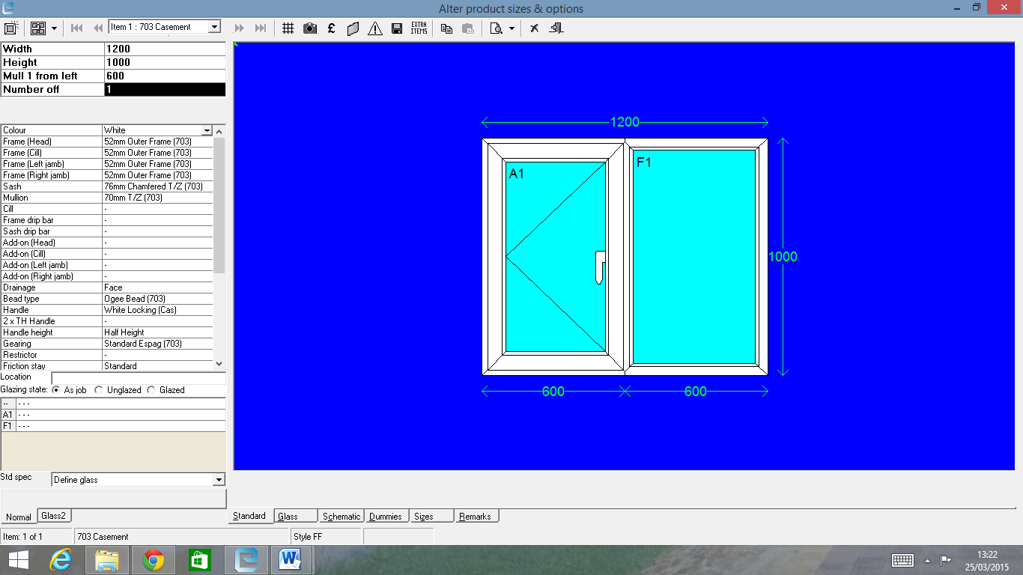
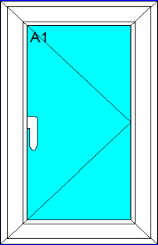
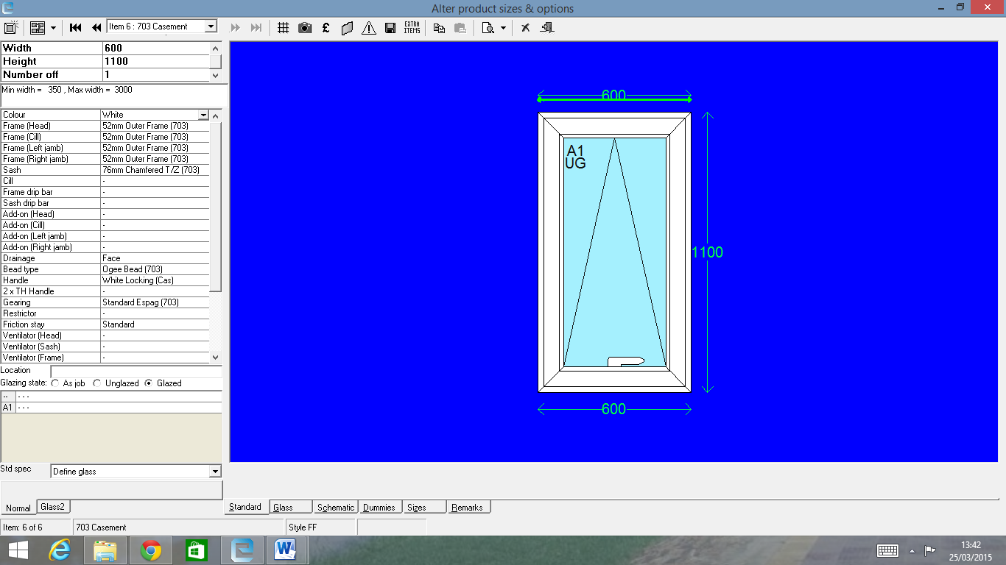
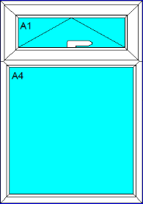

Style 1 Style 2 Style 3 Style 4
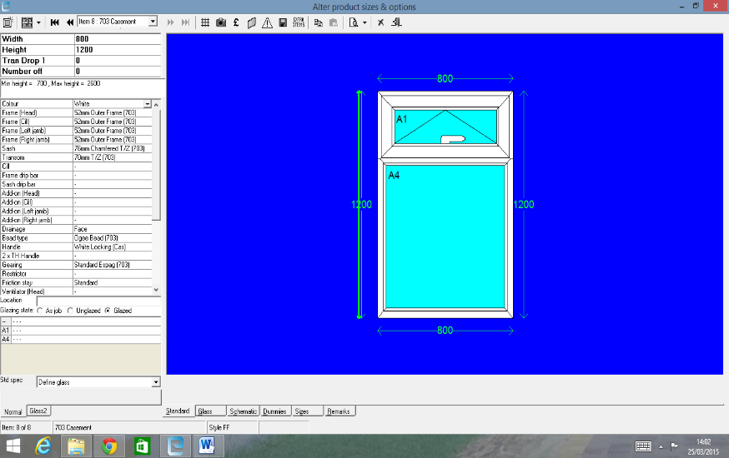
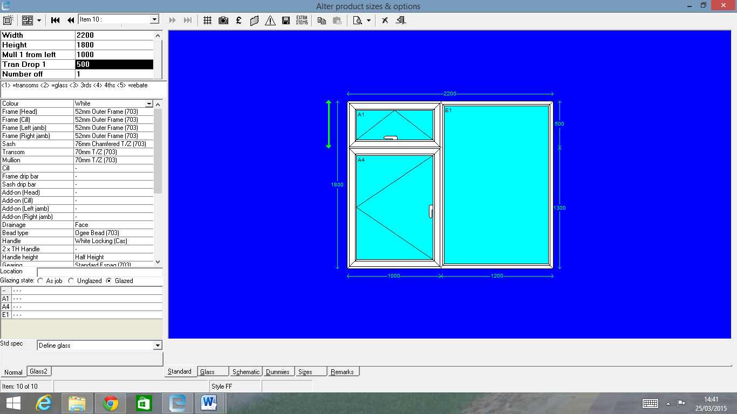
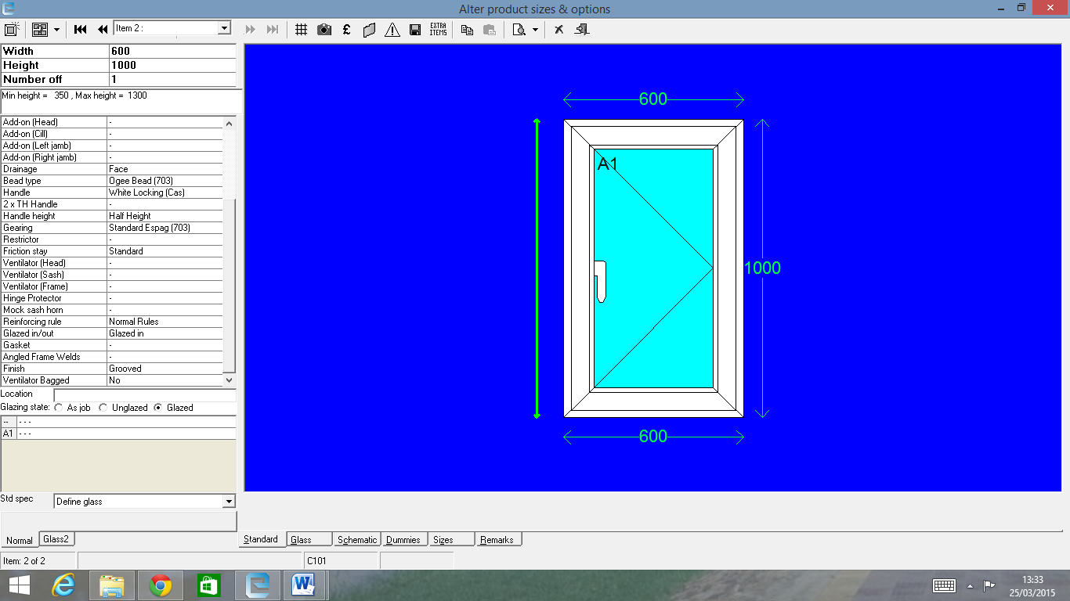
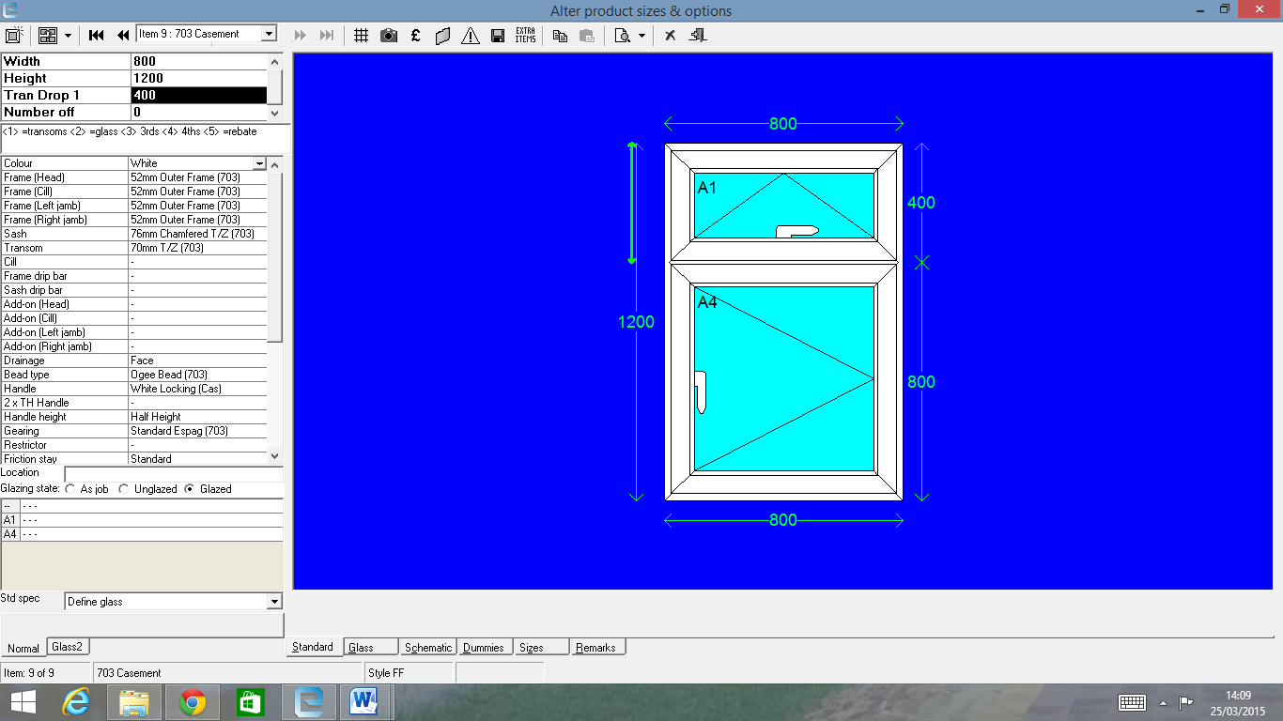

Style 5 Style 6 Style 7

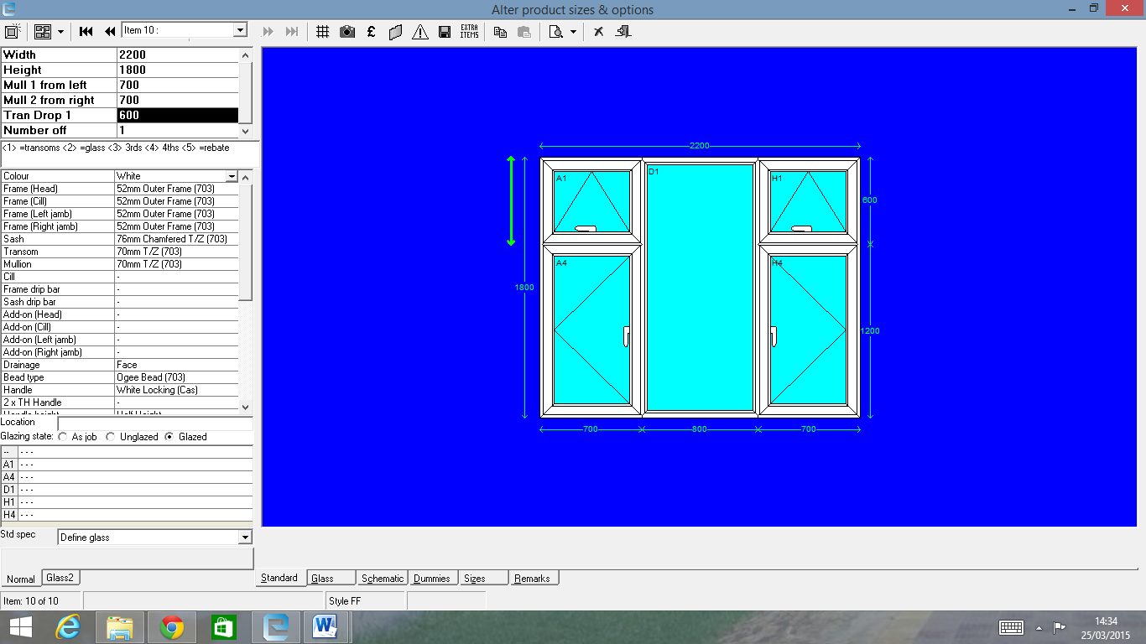

Style 8 Style 9

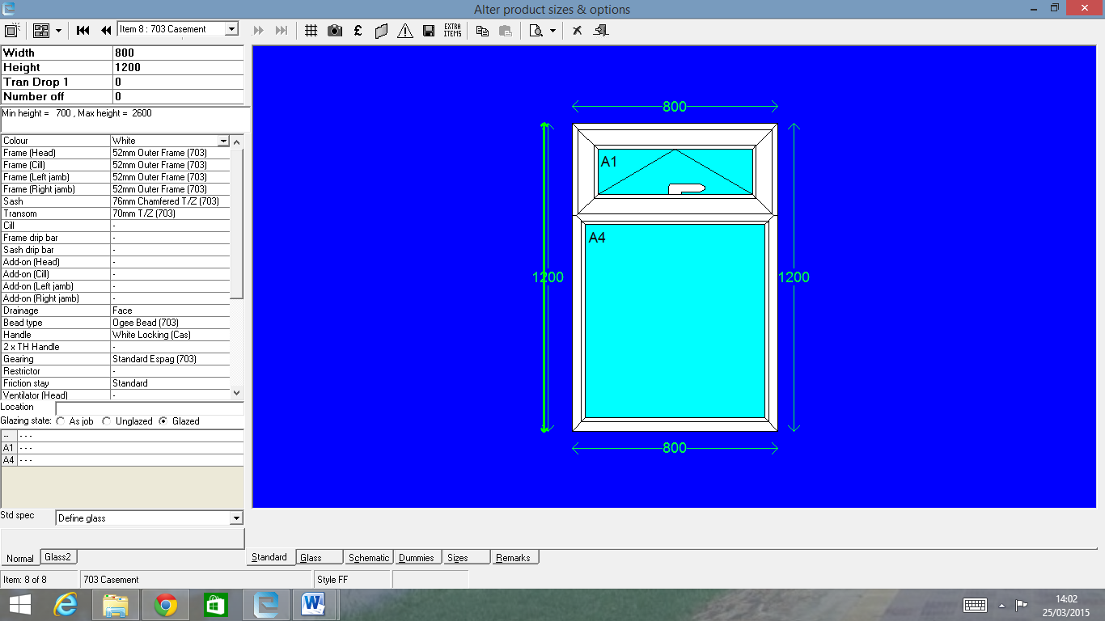

Style 10 Style 11

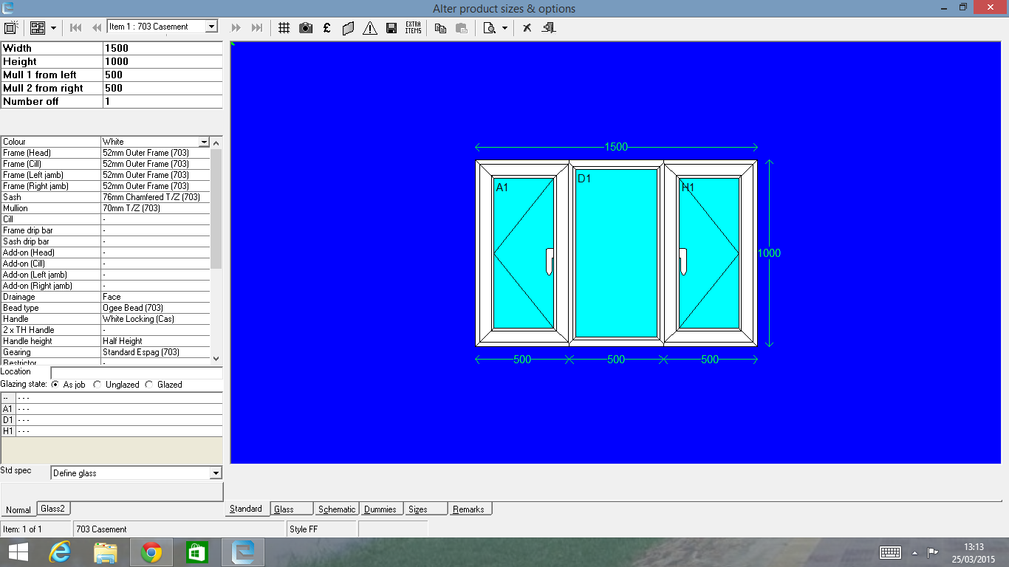

Style 12 Style 13
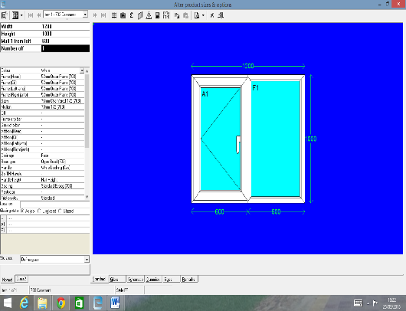
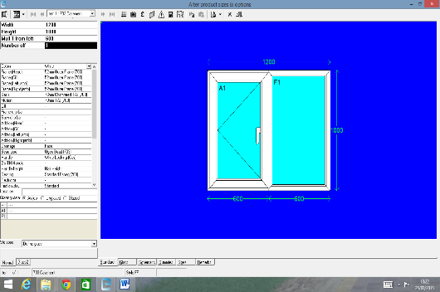
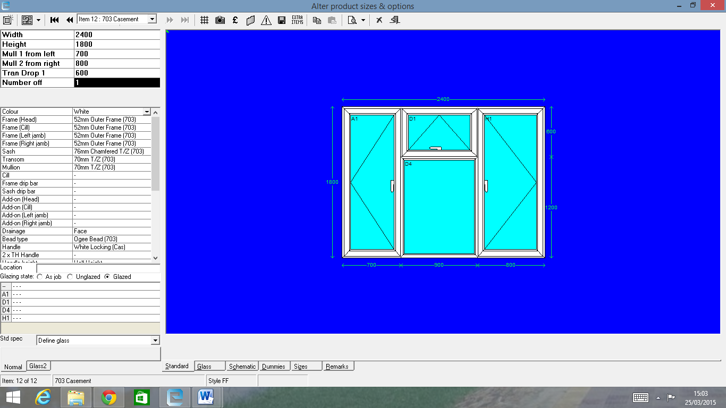

Style 14 Style 15

Style 16 Style 17

Typ
Style 18 Style 19

INFIL PANEL

Style 20

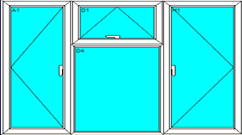
INFIL PANEL

Style 21
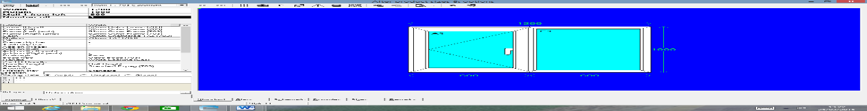

Style 22
Style 23
Style 24
Style 25

